# **Standard Operating Procedure to install REACT – Express- template Project for Windows Machine,**

**Text editor**: Visual Studio code

This the Boiler plate template project .This sets up a basic express.js backend with a react.js frontend with the same file structure that we use in the team.

Clone the code base from stash and download in the your local folder : REACT-EXPRESS-TEMPLATE.

Please note this folder contains 2 more folders:

1. Backend (Server)

2. Frontend (Client)

Using the Visual Studio code, Click a New window and open the Download folder from your Machine local Drive.

**Note:**

* Please avoid storing in clone code and accessing into visual code from one drive.
* **Note**: for Mac PC’s instead of using NPM , you have use YARN .
* No need to worry about existing 'package.lock.json' in the Backend/Frontend folder. You can keep it as it is. The below steps will Create/override these folders.

**BACKEND (server) setup:**

1. First, we will pick the backend folder(server) to setup – open a New terminal from VS code and

And start open the backend folder as below steps.

Below is the screen shot shows How I stores the folder.

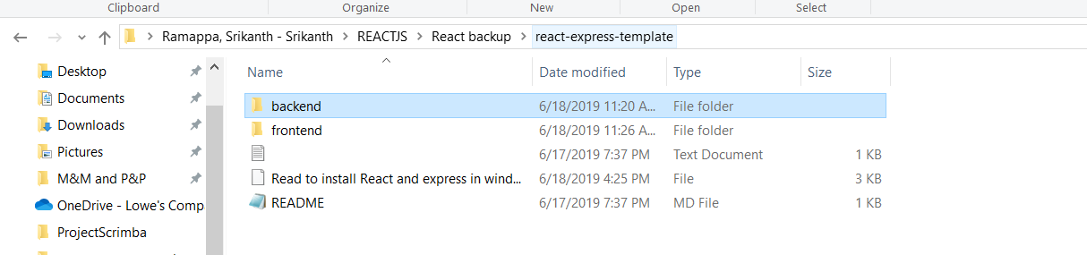

**In Terminal 1:**

1. PS C:\Users\sramapp\REACTJS\react-express-template> cd backend (open the backend folder)
2. PS C:\Users\sramapp\REACTJS\react-express-template\backend> npm cache verify (This will clear the cache)
3. PS C:\Users\sramapp\REACTJS\react-express-template\backend> npm install (This will create 'node_modules' and 'pacakge.lock.json' folder )
4. PS C:\Users\sramapp\REACTJS\react-express-template\backend> npm install express (to install express)
5. PS C:\Users\sramapp\REACTJS\react-express-template\backend> npm i nodemon --save-dev ( to install Nodemon server as save a dependency)

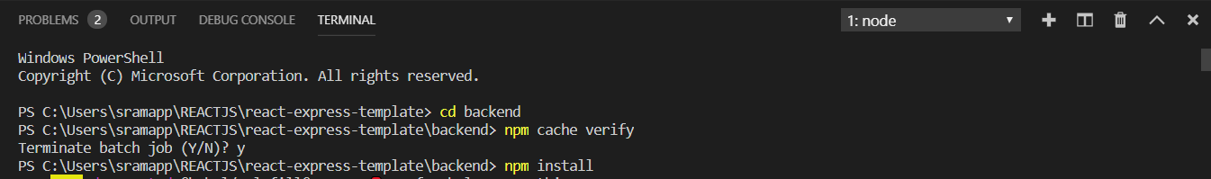





1. Once you have done the above step, open the Package.json file in VScode. And Add the "server": "nodemon server.js" in Package.json file (Backend folder) , as shown below

{

"name": "react-express-template-BACKEND",

"version": "1.0.0",

"description": "Express server for react-express-template",

"main": "server.js",

"scripts": {

"dev": "nodemon --exec babel-node server.js",

"start": "babel-node server.js",

"server": "nodemon server.js", **--------------> add this line**

"edge": "babel-node server.js"

},

"author": "Christopher Singer, DACI-DS",

"license": "ISC",

"dependencies": {

"@babel/core": "^7.4.3",

"@babel/node": "^7.2.2",

"@babel/preset-env": "^7.4.3",

"dotenv": "^7.0.0",

"express": "^4.17.1"

},

"devDependencies": {

"nodemon": "^1.19.1"

}

}

1. Open the Server.js file from backend folder, comment/remove the line import express from 'express'; instead of that add the line const express = require('express');

**Backend folder: Server.js**

* Remove the line: // import express from 'express';
* Add the line : const express = require('express');

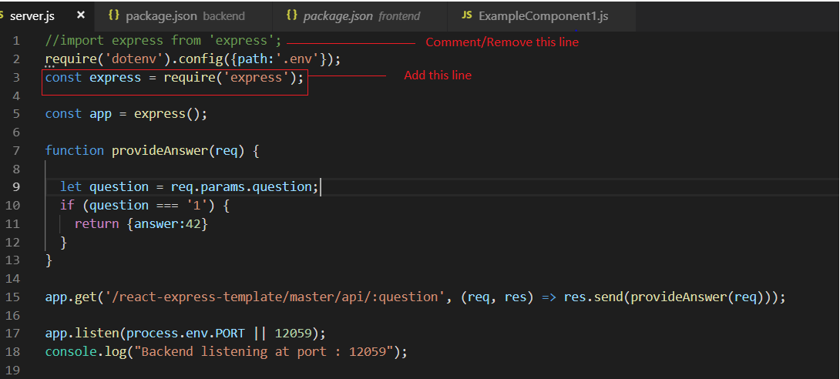

1. PS C:\Users\sramapp\REACTJS\react-express-template\backend> npm run server

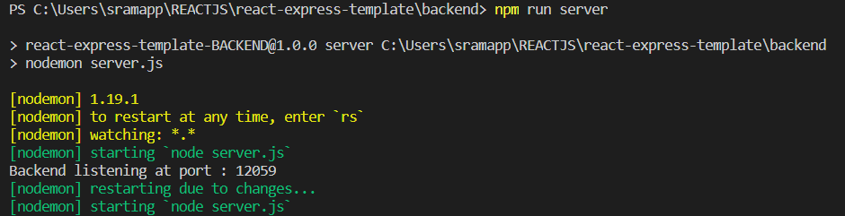

1. Once the server.js is started , automatically webpage will open with localhost:12059.

Incase internet explorer is not responding, Hit the below URL in Chrome to check server(backend) is responding.

<http://localhost:12059/react-express-template/master/api/1>

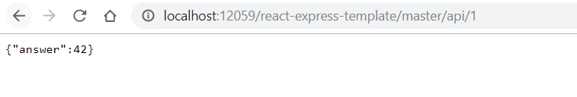

**FrontEnd (Client) setup:**

1. Now , we will pick the frontend folder(Client) to setup –
2. Take a backup of file from frontend/src which is having App.js , App.css, index.js, routes (folder contains - ExampleComponet1 )
3. open one more New terminal in the same window from VS code and And start open the frontend folder as below steps.

Below is the screen shot shows How I stores the folder.

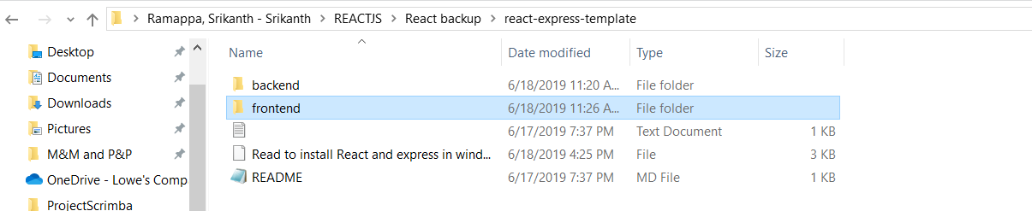

**In Terminal 2:**

1. PS C:\Users\sramapp\REACTJS\react-express-template> cd frontend
2. PS C:\Users\sramapp\REACTJS\react-express-template\frontend> npm install

( this will create 'node_modules' folder and package.lock.json)

1. Delete all the source files - Manually or the below command in the terminal under

In the folder

* C:\Users\sramapp\REACTJS\react-express-template\frontend>cd src
* C:\Users\sramapp\REACTJS\react-express-template\frontend\src>del *

then copy the App.js , App.css, index.js, routes (folder contains - ExampleComponet1 ) from the repository clone folder.

1. C:\Users\sramapp\REACTJS\react-express-template\frontend> npm start

> frontend@0.1.0 start C:\Users\sramapp\REACTJS\react-express-template\frontend

> react-scripts start

Starting the development server...

Compiled successfully!

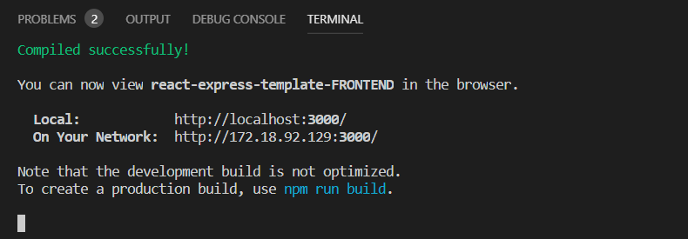

**Note:**

* **In case you got error related to Semantic UI – please install semantic-ui-react**

C:\Users\sramapp\REACTJS\react-express-template\frontend> npm install semantic-ui-react

1. Once we see the below Compiled successfully! Message in Terminal 2,

You can now view react-express-template-FRONTEND in the browser.

Local: http://localhost:3000/

On Your Network: http://172.18.92.129:3000/

Note that the development build is not optimized.

To create a production build, use npm run build.

Automatically webpage will open with localhost:3000.Incase internet explorer is not responding,

Hit the below URL in Chrome to check server(backend) is responding

<http://localhost:3000/>

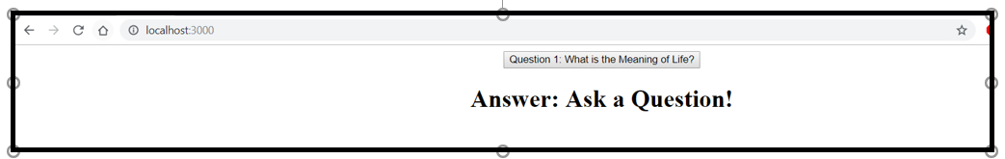

Once you click the button Question1: What is the meaning of Life , then it will send the request and it will get the response from the severs.js which is hardcode as **Answer:42**

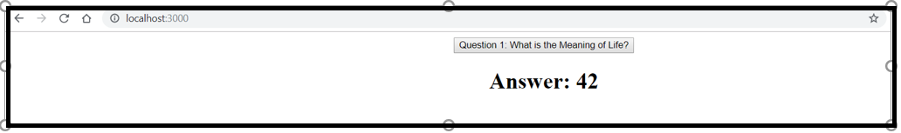

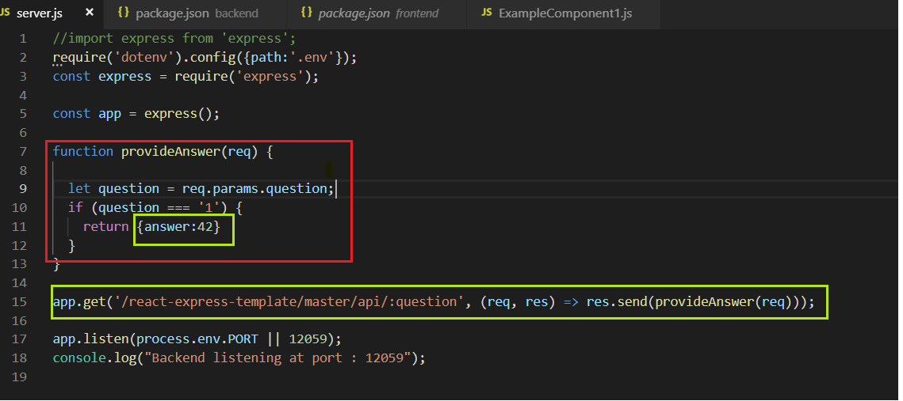

**Appendix:**

You can also verify using the response of the Api using (Inspect in chrome ) in the code to see the request value which was sent and the response as below:

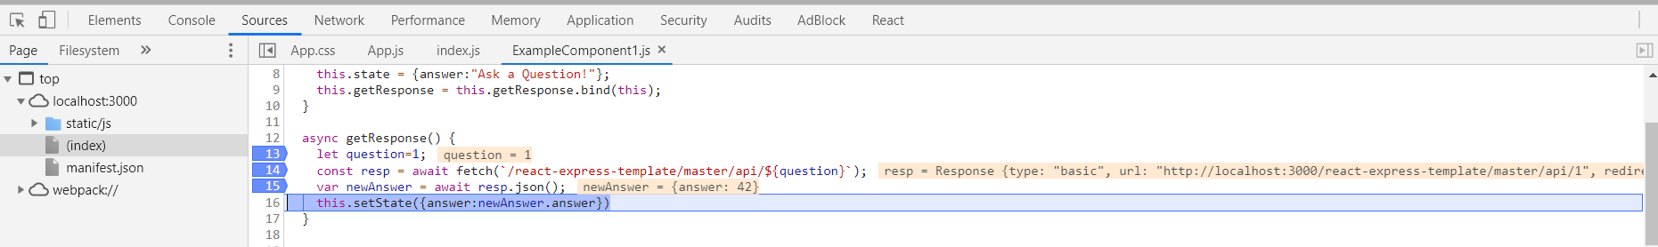

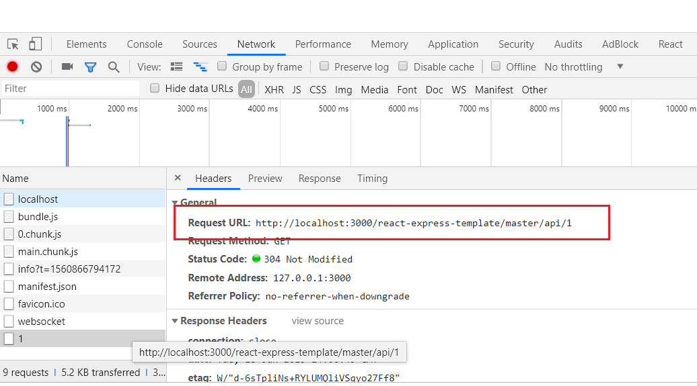

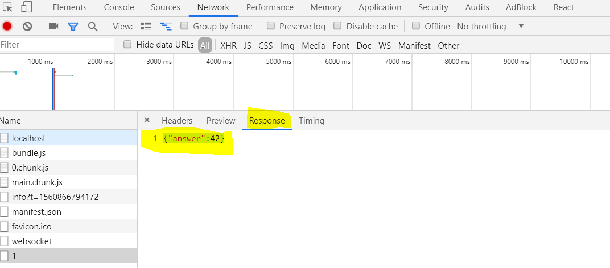

**Additional dependency installation**:

PS C:\Users\sramapp\REACTJS\React-express-sql\backend> npm cache verify

PS C:\Users\sramapp\REACTJS\React-express-sql\backend> npm install sqlite3

PS C:\Users\sramapp\REACTJS\React-express-sql\backend> npm i react-table

C:\Users\sramapp\REACTJS\React-express-sql\backend> node create_database.js

PS C:\Users\sramapp\REACTJS\React-express-sql\frontend> npm cache verify

PS C:\Users\sramapp\REACTJS\React-express-sql\frontend> npm install sqlite3

PS C:\Users\sramapp\REACTJS\react-express-template\frontend> npm audit fix

PS C:\Users\sramapp\REACTJS\react-express-template\backend> npm install -s sequelize sqlite3

PS C:\Users\sramapp\REACTJS\React-express-sql\frontend> npm i react-table